**Arduino – Drums**

**Circuit Diagram -**

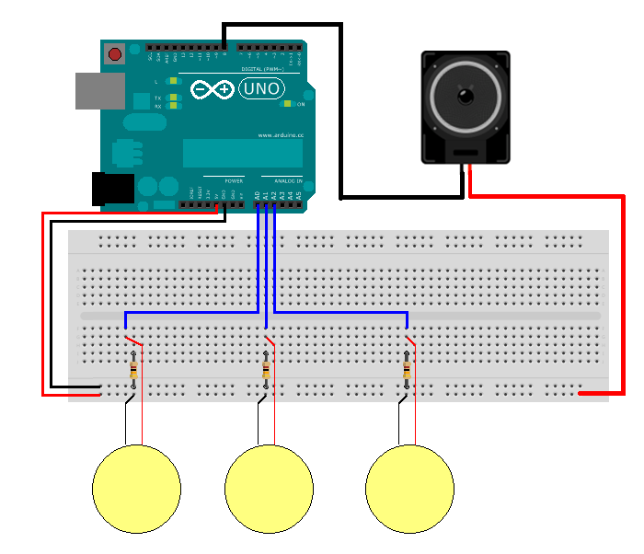

**Coding -**

#include "pitches.h"

const int threshold = 50;

int notes[] = {

NOTE_A5, NOTE_C4,NOTE_A3, NOTE_E4, NOTE_D4, NOTE_A6};

void setup() {

}

void loop() {

for (int thisSensor = 0; thisSensor < 6; thisSensor++) {

int sensorReading = analogRead(thisSensor);

if (sensorReading > threshold) {

tone(8, notes[thisSensor], 20);

}

}

}

**Pitches.h -**

/*************************************************

* Public Constants

*************************************************/

#define NOTE_B0 31

#define NOTE_C1 33

#define NOTE_CS1 35

#define NOTE_D1 37

#define NOTE_DS1 39

#define NOTE_E1 41

#define NOTE_F1 44

#define NOTE_FS1 46

#define NOTE_G1 49

#define NOTE_GS1 52

#define NOTE_A1 55

#define NOTE_AS1 58

#define NOTE_B1 62

#define NOTE_C2 65

#define NOTE_CS2 69

#define NOTE_D2 73

#define NOTE_DS2 78

#define NOTE_E2 82

#define NOTE_F2 87

#define NOTE_FS2 93

#define NOTE_G2 98

#define NOTE_GS2 104

#define NOTE_A2 110

#define NOTE_AS2 117

#define NOTE_B2 123

#define NOTE_C3 131

#define NOTE_CS3 139

#define NOTE_D3 147

#define NOTE_DS3 156

#define NOTE_E3 165

#define NOTE_F3 175

#define NOTE_FS3 185

#define NOTE_G3 196

#define NOTE_GS3 208

#define NOTE_A3 220

#define NOTE_AS3 233

#define NOTE_B3 247

#define NOTE_C4 262

#define NOTE_CS4 277

#define NOTE_D4 294

#define NOTE_DS4 311

#define NOTE_E4 330

#define NOTE_F4 349

#define NOTE_FS4 370

#define NOTE_G4 392

#define NOTE_GS4 415

#define NOTE_A4 440

#define NOTE_AS4 466

#define NOTE_B4 494

#define NOTE_C5 523

#define NOTE_CS5 554

#define NOTE_D5 587

#define NOTE_DS5 622

#define NOTE_E5 659

#define NOTE_F5 698

#define NOTE_FS5 740

#define NOTE_G5 784

#define NOTE_GS5 831

#define NOTE_A5 880

#define NOTE_AS5 932

#define NOTE_B5 988

#define NOTE_C6 1047

#define NOTE_CS6 1109

#define NOTE_D6 1175

#define NOTE_DS6 1245

#define NOTE_E6 1319

#define NOTE_F6 1397

#define NOTE_FS6 1480

#define NOTE_G6 1568

#define NOTE_GS6 1661

#define NOTE_A6 1760

#define NOTE_AS6 1865

#define NOTE_B6 1976

#define NOTE_C7 2093

#define NOTE_CS7 2217

#define NOTE_D7 2349

#define NOTE_DS7 2489

#define NOTE_E7 2637

#define NOTE_F7 2794

#define NOTE_FS7 2960

#define NOTE_G7 3136

#define NOTE_GS7 3322

#define NOTE_A7 3520

#define NOTE_AS7 3729

#define NOTE_B7 3951

#define NOTE_C8 4186

#define NOTE_CS8 4435

#define NOTE_D8 4699

#define NOTE_DS8 4978